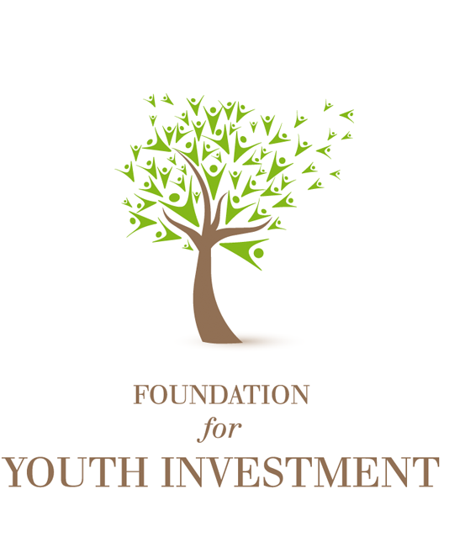
Cultural Relevancy in
Outdoor Youth Programming
A Report on the Statewide
Discussion Series

Sponsored by the Foundation for Youth Investment
April – November 2011

Table of Contents

Executive Summary 1
Introduction 3
Background 3
Cultural Relevancy in Outdoor Youth Programming 3
Sponsoring & Facilitating Organizations 4
Participating Organizations 4
Discussion Series Details 4
Structure & Content of the Discussions 5
Meeting Design 5
Relevancy Defined 5
Goals for the Discussions 5
Opening Question 5
Deeper Questions 6
Challenges to Building Culturally Diverse Programs – Initial Responses 6
Strategies for Building Culturally Diverse Programs – Initial Responses 7
A Framework for Analysis & Recommendations 7
Organizational Challenges 7
Social Challenges 8
Responses to Organizational Challenges 8
Responses to Social Challenges 8
Conclusion 9
Next Steps 9
Appendix: Notes from the Discussions 10
Staffing 10
Community 12
Youth & Family 14
Boards of Directors 15
Curriculum 17

Executive Summary
This report summarizes the content of a series of statewide discussions on cultural relevancy sponsored by the Foundation for Youth Investment (FYI) in 2011. The purpose of this report is to provide stakeholders throughout California’s outdoor youth provider community with an overview of the structure and content of the meetings, as well as plans for future FYI-sponsored activities.
In 2011, FYI sponsored a series of five regional discussions with outdoor youth providers in San Francisco, Sacramento, Los Angeles, San Diego, and Fresno. FYI partnered with the following organizations: San Francisco Presidio Trust; Sierra Health Foundation; USDA Forest Service; Central California Consortium; Fresno Conservation Corps; Frieda C. Fox Family Foundation; Children’s Nature Institute, Los Angeles; the San Diego Foundation; and REI. Be The Change Consulting, an Oakland-based youth-development consulting firm, and Youth Development Network, a Sacramento-based organization that supports youth providers with training and networking activities, facilitated the discussions.
The call for cultural relevancy comes from outdoor youth providers in response to the changing demographics of California, which now has a majority-minority population. Outdoor youth providers recognize that their programs may not be as culturally relevant given these rapidly changing demographics; they are looking for ways to come together, share ideas, and address how to develop more culturally relevant programs to meet the needs of their participants.
The discussions provided an opportunity to better understand what cultural relevancy means for the outdoor education field, where program participants originate from, how organizations are addressing the needs of minority communities, and how relevant the organizations are to under-represented youth. The discussions were well attended, lively, and productive. Participants hailed from a variety of organizations and contributed a range of views, values, and recommendations.
The discussions were built on this working definition of relevancy developed by the session participants: “The skill or competency of an organization to create programs and have staff and approaches that are representative of the communities served.” The discussion series sought to bring outdoor youth providers together to share their questions, ideas, and experiences with cultural relevancy and begin building a set of best practices for the field. Following are the key questions the discussion series sought to answer:
- In what ways is the outdoor educational field relevant to the population it serves?
- In what ways is this field not relevant to the population it serves?
- What needs to shift in our field to increase participation in outdoor activities from under-represented communities?

The first meeting in San Francisco, hosted by the Presidio Trust, featured a panel discussion of directors from youth provider organizations and program participants. After receiving feedback from attendees at the San Francisco meeting, FYI changed the structure of the remaining four meetings to allow participants more time to meet in small discussion groups. A key element of the Sacramento, San Diego, and Fresno meetings was an activity called the “The Five Whys,” during which participants began with a central intriguing question and then asked a series of follow up “why” questions in small groups. Through this process, participants developed an understanding of the deeper implications and complexities of the issues. Follow-up questions covered topics ranging from partnering with school systems to creating leadership and employment ladders for under-represented youth. Participants also shared their challenges with and strategies for building culturally diverse programs. As the conversations deepened, two categories of challenges began to emerge – organizational (having to do with the structure and administration of programs) and social (having to do with community constraints).
The appendix of this report includes tables of raw data from the discussions. The key questions posed to participants, as well as their responses and recommendations, are organized into five areas of concern: staffing, community, youth and family, boards of directors, and curriculum. The responses and recommendations are presented in the words of the participants.
Meeting participants agreed that the issues of cultural relevancy among outdoor youth providers are serious and need immediate attention. Participants recognized that the health and well-being of youth across the state is tied to their organizations’ ability to attract youth from California’s burgeoning minority populations. As a first step, participants recommended recruiting youth from under-represented groups into mainstream programming. At the same time, the field should continue to examine the structural and social challenges of developing more relevant programming including the following: hiring and developing more diverse, culturally competent staff; building relationships with the community; engaging with youth; developing curriculum; and ensuring more diverse representation on boards of directors. Participants noted that both outdoor youth providers and the funders who support them should address these challenges jointly to ensure relevant program delivery and organizations.
The outcomes of these discussions are the first step in developing a set of cultural-relevancy best practices for the field. In 2012/2013, with the help of FYI, local organizations will facilitate four to six smaller convenings in each region of the state. To bring these issues to a broader audience, FYI will develop panel discussions on cultural relevancy in youth programming at conferences throughout California and the nation. FYI is also in the planning stage of developing an online tool for organizations to measure their own relevancy.

Introduction
In 2011, the Foundation for Youth Investment (FYI) sponsored a series of five regional discussions with outdoor youth providers throughout California. The discussions provided an opportunity to better understand what cultural relevancy means for the outdoor education field, where program participants originate from, how organizations are addressing the needs of minority communities, and how relevant the organizations are to under-represented youth. The discussions were well attended, lively, and productive. Participants hailed from a variety of organizations and contributed a range of views, values, and recommendations. The outcomes of these discussions are the first step in developing a set of cultural relevancy best practices for the field.

Background

Cultural Relevancy in Outdoor Youth Programming
Currently, California is one of the few states in the country with a majority-minority population. According to the 2010 US Census, approximately 41% of the state’s population identifies as White, 39% Hispanic, 13% Asian, and 6% Black, with the remainder made up of other ethnicities. And in California’s cities, there is even greater diversity than these current statewide statistics illustrate. These numbers represent a dramatic demographic shift. Just 10 years earlier in 2000, Whites represented approximately 47% of the population, with 32% identifying as Hispanic, 11% Asian, and 7% Black.
These changing demographics are presenting new challenges to outdoor youth providers across California as they grapple with issues of cultural relevancy in their programming and staffing. In many youth organizations, the ethnic makeup of staff does not mirror the diversity of the state’s youth. Organizations across the state have cited this demographic disconnect between staff and youth as a major barrier to achieving their missions. When programs aren’t relevant to the communities they serve, participation decreases, which puts many youth at risk; outdoor activities and time spent in nature are essential to the physical, emotional, and social development of our youth. In response to the field’s call for solutions to this challenge, the Foundation for Youth Investment, Be The Change Consulting, and Youth Development Network developed a discussion series. The discussions brought youth providers together to examine the issues surrounding cultural relevancy from the perspective of practitioners, youth, and communities.

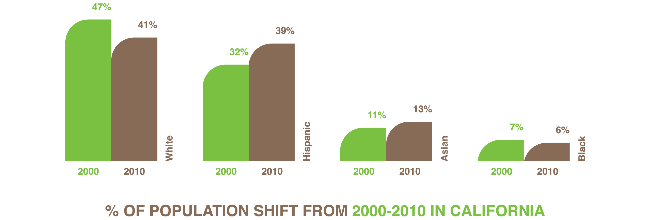
Sponsoring & Facilitating Organizations
Partner organizations included: San Francisco Presidio Trust; Sierra Health Foundation; USDA Forest Service; Central California Consortium; Fresno Conservation Corps; Frieda C. Fox Family Foundation; Children’s Nature Institute, Los Angeles; the San Diego Foundation; and REI.
The discussions were facilitated by Be The Change Consulting, an Oakland-based youth development consulting firm, and Youth Development Network, a Sacramento-based organization that supports youth providers with training and networking activities.

Participating Organizations
The discussions were well attended. Each city registered an average of 75 participants, ranging from practitioners and directors to executive directors and state policy makers. Representative organizations ranged from outdoor adventure agencies to departments of parks and recreation, community-based organizations, schools, and environmental conservation and advocacy organizations.

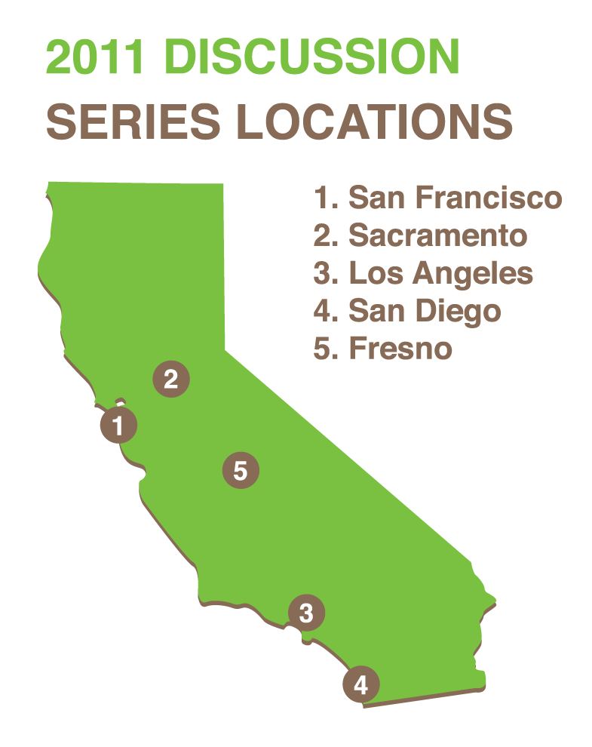
Discussion Series Details
The discussions took place in five cities across California. Local partners hosted the discussions, ensuring that the sessions would be tailored to the social, demographic, and cultural contexts of the cities. The cities, dates, and hosts follow:
- San Francisco, April 26, 2011 – Presidio Trust
- Sacramento, August 18, 2011 – Sierra Health Foundation
- Los Angeles, October 17, 2011 – Frieda C. Fox Family Foundation and Children’s Nature Institute
- San Diego, October 19, 2011 – San Diego Foundation and REI
- Fresno, November 10, 2011 – USDA Forest Service, Central California Consortium, and Fresno Conservation Corps

Structure & Content of the Discussions

Meeting Design
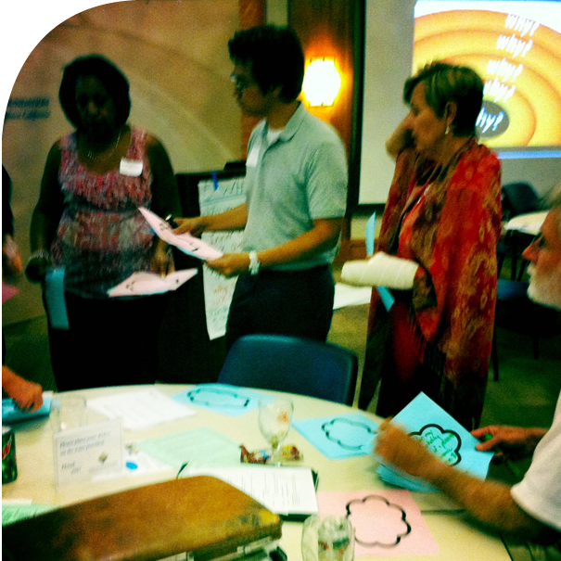
The discussion series began in San Francisco with a meeting hosted by the Presidio Trust. This first meeting featured a panel discussion of directors from youth provider organizations and program participants. After receiving feedback from attendees at the San Francisco meeting, FYI changed the meeting structure to allow participants more time to meet in small discussion groups. The remaining four meetings were more participant-centered and active. This section of the report summarizes the content of all five discussions.

Relevancy Defined
The discussions were built on this working definition of relevancy developed by the session participants: “The skill or competency of an organization to create programs and have staff and approaches that are representative of the communities served.”

Goals for the Discussions
The primary goals of this discussion series were to bring outdoor youth providers together to share their questions, ideas, and experiences with cultural relevancy and to begin building a set of best practices for the field. Following are the key questions the discussion series sought to answer:
- In what ways is the outdoor educational field relevant to the population it serves?
- In what ways is this field not relevant to the population it serves?
- What needs to shift in our field to increase participation in outdoor activities from under-represented communities?

Opening Question
The facilitators began by asking participants in each meeting to respond to an opening question: What makes an organization relevant to the communities it serves? The following responses illustrate the variety of views held by participants:
- The staff’s ability to build relationships with youth and their families that incorporate their culture, background, and upbringing.
- The knowledge of cultural norms and how they inform young people’s behavior and choices.
- The understanding that staff who grew up in the same types of communities as the youth will intuitively “get it” more than someone who is transplanted from a different background – there are some things you just can’t teach.
- The knowledge of how to make the outdoors feel less intimidating to young people who come from places where the outdoors in their immediate community may not be safe or where parks and hiking trails are not as easily accessible (even in California).
- Curriculum, activities and stories that make youth feel like they are engaging in something that is part of their own indigenous history.

Deeper Questions
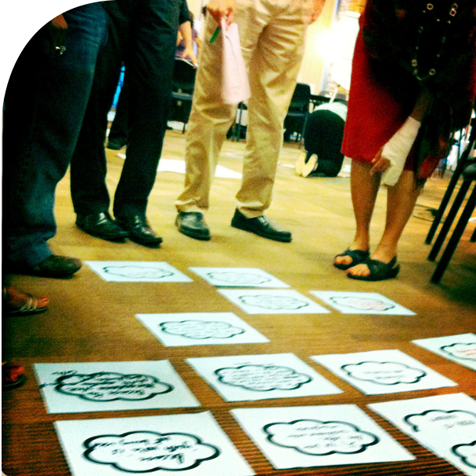
As the structure of the meetings evolved, Adrian Ruiz, executive director of the Youth Development Network in Sacramento, was brought on to co-facilitate discussions in Sacramento, and San Diego. To engage participants in an active process of questioning and reflection, Mr. Ruiz introduced a process called “The Five Whys,” during which participants began with a central intriguing question and then asked a series of follow up “why” questions in small groups. Through this process, participants developed an understanding of the deeper implications and complexities of the issues. Here are some of the follow-up questions participants generated:
- How do we better engage the school system in outdoor education connected to science, etc.?
- How do we overcome obstacles to partnerships between community-based organizations and outdoor education providers?
- How can we shift the environmental dialogue to be more responsive to the needs of marginalized communities?
- What are some good models that create leadership and employment ladders for youth of color?
- What are the ideal recruitment and training strategies to diversify staff in this work?
- How does the culture of the outdoors need to shift or transform to become more inclusive of communities of color? (Why do we value rugged, solitary, individualism?)
- How do we hold organizations accountable for increasing their cultural relevancy through standards or metrics?

Challenges to Building Culturally Diverse Programs – Initial Responses
Participants spoke to the challenges of building culturally diverse programs. Here are some of their thoughts:
- “Organizations need to provide a diversity of staff. Someone who looks like the youth or comes from his or her same background or community may be an important first point of contact. But once a young person is connected to the organization and the vision of the outdoors, diverse staff can be just as effective.”
- “With regards to the experience of Native youth, lumping all of them into one category is de-humanizing because each Native culture has its own traditions and practices. There are complicated feelings that can arise when outsiders teach youth about their own culture. Youth often feel shame that they do not know this information for themselves.”
- “Organizations who are trying to work with youth of color need to locate themselves in the communities of the youth – where rent is cheaper anyway!”
- “When I flip through outdoor magazines I hardly see a person of color. We need to really think about what we are selling and to whom we are selling it in this field. It’s time for a cultural makeover.”

Strategies for Building Culturally Diverse Programs – Initial Responses
Participants who had more experience working with diverse populations answered with some of their strategies for success. They recommended the following:
- Making connections to environmental advocates from indigenous communities to shake the impression that environmentalists are “grubby white dudes who don’t shower.” Reminding youth that the first “tree huggers” were Indian women who surrounded ancient and holy trees, holding hands and dressed in saris to prevent them from being cut down.
- Offering a slow and steady progression to outdoor involvement by scaling up the level of adventure from activities like barbeques and family picnics in parks, to hiking, camping, and finally white-water rafting in class-four rapids.
- Making connections between an increased rate of asthma and obesity in communities to local companies polluting the air and waters. Then, engaging young people in environmental education and activism to create meaningful change in their own communities.

A Framework for Analysis & Recommendations
As the conversations deepened, issues of cultural relevancy began to fall into two categories of challenges – organizational (having to do with the structure and administration of programs) and social (having to do with community constraints). There is interplay between these categories as the structure of organizations determines the population served, while constraints within communities determine the population organizations can draw from. Participants used this analytical framework to shape the discussion.

Organizational Challenges
Participants cited the following organizational challenges:
- Staff who are unable to make real connections with youth from underserved communities.
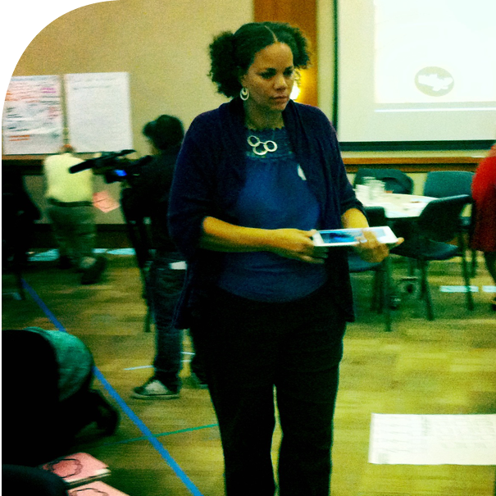
- Program design and curriculum that feel irrelevant to diverse participants.
- Organizations and companies that do not market to a diverse clientele.
- Boards of directors that are not diverse and show little concern for issues of cultural relevancy.
- Lack of funding for leadership development and staff recruitment of people from under-resourced backgrounds.
- Lack of infrastructure required to retain staff from under-resourced backgrounds.
- Lack of resources and methods necessary to engage a range of participants and families, including those from under-resourced backgrounds.


Social Challenges
Participants cited the following social challenges:
- Lack of effort from diverse communities in pressuring organizations to change.
- Low numbers of people from under-represented communities involved in outdoor programming and activities, leading to a limited talent pool from which organizations can recruit staff.

Responses to Organizational Challenges
Small-group discussions led to deeper analyses of each challenge and the development of recommendations. Here are some of the ideas shared in response to organizational challenges:
- Create a flexible leadership award for organizations to support the mentorship and capacity building for diverse young leaders, with the aim of integrating two people from under-represented groups into their executive team within two years.
- Invite leaders in the development of excellent culturally responsive and tailored outdoor education lesson plans to submit ideas and develop a series of comprehensive curriculum guides. Hold a series of trainings or conferences to engage statewide practitioners in dialogues about how to integrate this curriculum into their existing programming.
- Establish a “cultural transformation” learning community with leaders of environmental organizations in each city to explore organizational systems, structures, and culture through the lens of cultural relevance. As part of this series, engage each organization in a reflection on its board make-up, marketing, and messaging strategies. Coach leaders in strategies for creating a more multi-cultural work environment.
- Create educational and organizational assessments that include cultural relevancy as a key metric.

Responses to Social Challenges
Here are some of the ideas participants shared in response to social challenges:
- Cultural competency trainings often leave participants feeling blamed, isolated, or hurt.
- The field needs more opportunities to come together and discuss stories of isolation or challenge faced by minority groups attempting to engage in outdoor education services.
- The field needs spaces where current leaders can share their challenges in attempting to create change and better understand why their efforts are not working.
- Honest dialogue and authentic change comes from relationships across differences – the willingness to be transparent, courageous, and vulnerable is vital.

Conclusion
The issues of cultural relevancy among outdoor youth providers are serious and need immediate attention. The health and well-being of youth across the state is tied to the ability of outdoor youth providers to attract participants from California’s burgeoning minority populations. Providers can begin by actively recruiting participants from under-represented groups into mainstream programming. At the same time, the field needs to continue examining the structural and social challenges of developing more relevant programming. Those challenges include hiring and developing more diverse, culturally competent staff; building relationships with the community; engaging with youth; developing curriculum; and ensuring more diverse representation on boards of directors. Outdoor youth providers and the funders who sustain them should address these challenges jointly to ensure sustainable programs and organizations.

Next Steps
Building on the success of this discussion series, FYI will work with local organizations across California to develop an ongoing dialogue around cultural relevancy. In 2012/2013, with the help of FYI, local organizations will facilitate four to six smaller convenings in each region of the state. To bring these issues to a broader audience, FYI will develop panel discussions on cultural relevancy in youth programming at conferences throughout California and the nation.

Appendix Notes from the Discussions
The following tables include raw data from the five-discussion series on cultural relevancy in outdoor youth programming. The key questions posed to participants as well as their responses and recommendations have been organized into five areas of concern: staffing, community, youth and family, boards of directors, and curriculum. The responses and recommendations are presented in the words of the participants.

Staffing
Questions Asked:
- Why aren’t the leaders in this field as culturally diverse as the population of the state?
- Why is there a lack of resources for people of color to become outdoor experts?
- Why is there a lack of culturally competent staff?
- Why is it important to understand and be aware of another culture’s norms, values, and priorities?

Responses | - Outdoor education may not be seen as an acceptable career by some ethnic groups  - Language barriers  - Outdoor organizations tend to require bachelor degrees to teach in their programs  - Many likely candidates are too qualified for the level of pay, or don’t want to take a job at the starting salary level  - Employers value academic experience over cultural experience  - We have not fostered, welcomed, and mentored a diverse staff and there is a perception that the field is closed and/or irrelevant to people of color.  - Lack of diversity in age and ethnicity in organizations prohibit awareness, analysis, or capacity to create a shift  - Organizations don’t recognize it as an issue – lack of education  - Lack of training focused on cultural relevance  - Organizations/individuals fear and/or are unwilling to address cultural relevancy and implement strategies  - To understand that other cultures have other needs as opposed to yours  - To show you are making an effort to understand them  - To not be offensive  - To understand why they might do things a certain way  - To learn more and be able to socially interact with other cultures  - Qualifications and expertise are skewed toward homogenous groups  - Tenured staff are not retiring/lack of opportunity
Recommendations | - We need to re-frame cultural relevancy as a core competency and a priority  - Hold conversations about benefits and publish case studies and data about what is possible with a more diverse staff  - Outdoor education as a career isn’t widely recognized by the community  - Target the local community for local jobs  - Recognize and celebrate organizations that prioritize hiring locally  - Develop fellowship opportunities for college students at local campuses and offer stipends  - Identify community training programs  - Focus on middle/high school students  - Provide more volunteer opportunities for high schools  - Develop a program for agencies to collaborate on mentoring youth, who are interested in the field  - Develop deeper pathways for youth to stay in the field, such as jobs, internships, leadership roles for diverse youth  - Establish professional groups for people to network and share resources/opportunities  - Ensure the concept is infused in everything you do  - Offer trainings with tangible how-tos and strategies  - Establish culturally relevant outreach – find ways to go to them instead of waiting for them to come to us  - Provide opportunities for training and information sharing that isn’t top-down to shift the paradigm of who is considered to be a leader  - Translating your message into a context they understand  - Understand where your demographic is coming from  - To put other cultures at ease and help them feel comfortable  - Learn to respect other cultures even though you may not fully understand them  - Educate yourself with cultural norms and values of a community  - To understand what kind of “education” they need, not assuming people come from the same place as you  - Being culturally aware by immersing yourself into a community  - To understand what is important to them  - We can learn a lot from other cultures in order to better ourselves  - Having a dialogue with community and getting to know them  - To avoid alienating people from another culture  - Be open-minded and be humble in order to show you are willing to learn about another group or community.

Community
Questions Asked:
- Why should programs consider the interests and needs of the community?
- Why is ensuring community involvement in a sustainable and flexible manner so difficult?
- Why don’t people/families participate in our environmental programs?
- Why is there a lack of community involvement?
- Lack of funding for transportation limits access. Why is it difficult to fund transportation?

Responses | - There won’t be longevity or long-term sustainability in the outdoor movement  - Generating engagement  - Community knows most what it needs  - Community empowerment  - Feedback loop  - Everyone involved (staff, supervisors, community served, etc.) is afraid of getting out of his or her comfort zone.  - Lack of support from managers/supervisors for staff to take new approaches and risks  - Lack of opportunity and lack of knowledge of the opportunities for community engagement  - Not willing to make long-term more nebulous outcomes a priority  - Language and cultural barriers  - No grant for transportation  - Not as important as health/wellness and jobs
Recommendations | - Lead by example, provide an environment that allows people to feel safe in stepping outside of their comfort zone and reward/acknowledge those who do  - Create more community outreach, involve community members in this process  - Take steps to secure comfortable, safe, familiar locations to connect with community members  - Listening to community on their terms by meeting with them at convenient times for them, using simple language  - Provide staff training on cultural literacy and sensitivity to equip staff with the knowledge to adjust programming to meet the community where they are  - Develop a feedback loop between programming and the community by addressing issues that affect community and communicate back  - Build leadership pyramids within the community  - Collaborate with community and stakeholders and facilitate communication  - Put it in the mission and vision statement and include long term outcomes in staff training  - Recruit new managers and acknowledge current managers who are willing to allow staff to take innovative risks  - Bring on staff and volunteers who can speak the language and understand the culture  - Create a tax to improve public transportation to the outdoors  - PR and marketing to promote significance to health and wellness

Youth & Family
Questions Asked:
- Why aren’t current marketing/media efforts reflective of youth of color? Why are youth of color not participating in programs?
- Why do inner city/low-income kids have the least access to outdoor programs?

Responses | - Lack of money, or perception that this is too expensive  - Lack of parenting – won’t take time to transport child  - Burned-out  - Uneducated  - Fear  - Lack of knowledge of programs/causes  - Lack of networking and sharing resources  - Laziness  - Program location  - Detached higher-ups who don’t see this as a problem, and so don’t do anything about it, which creates a vicious cycle  - Lack of training opportunities/experience for potential staff from diverse backgrounds  - High education costs  - Low importance/respect for this work  - Low wages limit those who can afford to work in the field to the privileged who don’t have as many financial responsibilities or come from more wealthy backgrounds  - They don’t know there is a lack of marketing  - There is a generation gap within the current practitioners  - Organizations don’t collaborate – same marketing to the same audience  - Unwilling to pay or invest in PR or staff time  - Takes too much time and money to get information out  - Hard to get volunteers to help – funding and staffing cuts

Recommendations | - Get involved in career days  - Develop a Facebook presence  - Assess program locations – if they are too remote it will be hard to recruit the right staff  - Close the gaps between administration and program staff  - Make it a grant/organization policy for higher-level staff to spend time in the field with program staff  - Increase pay and social popularity of the work  - More scholarships and on-the-job training through fellowships  - Lack of shared resources for training and development  - Create more opportunities for cross-organizational collaboration  - Attracting skilled marketing staff  - Change who is making final decisions  - Diversity  - Advertise the rewards other than pay  - Build cultural competency and fluency into job descriptions so life experience and diversity is valued as a core requirement to be a great candidate  - Investment in latest and greatest technology and training to go with it  - Partner with other organizations already providing the training  - Expect them to come to us – assume they know who we are  - Be consistent with new information going out  - Stop assuming they will come to us –assume they don’t know  - Don’t’ be afraid to let someone else own a project  - Encourage creativity and strive to create a culture of flexibility  - Reward those who try new things  - Relationship building, building trust, opportunities for people to come together, develop family program  - Develop progressive programming  - Reach out and recruit youth to participate in trainings on the outdoors and provide positive experiences to motivate them to stay in outdoor programming  - Create tailored marketing and PR using ethnic media  - Make outreach relevant to the community  - Need to make a regional transportation plan versus just transport to urban areas  - Continued development of urban bike paths including access to natural areas  - Partner with hospitals to fund outdoor experiences/access as a way to prevent future health issues  - Create incentives for outdoor participation (at stores for programs)  - Local greening—lack of green space in their neighborhoods for programs to operate  - School gardens, community gardens  - School foresting, watershed accessible surfaces  - Revitalizing vacant lots  - Earth fair section for groups that focus on getting kids outside  - Marketing what we do have to under-served communities  - Integrating environmental/outdoor experiences  - Pass NCLI (no child left inside)  - State environmental literacy plan implemented (when it’s done)  - Focus on nature literacy in programs

Boards of Directors
Questions Asked:
- Why do boards need to reflect communities of color?
- Why do boards lack cultural diversity?
- Why should boards be more engaged with communities served?

Responses | - Board itself will be better able to support the organization if mission/people are tightly connected  - They share experience with and a stake in the community  - To serve as a model to youth of color  - To build capacity within the community  - Organizations feel that skill set is heavily weighted to community connections for raising money  - We don’t look at this as progression and investment; current board members attract like board members  - Organizations unwilling or uncomfortable when it comes to changing board composition  - Scarcity of diverse prospects with specific skill sets needed  - Most boards are initially focused on raising money  - Sometimes difficult to find individuals from particular cultures to serve
Recommendations | - Improve networking and active, strategic recruitment  - Reward, celebrate, and study organizations that have established a diverse leadership  - Can lead community outreach efforts (businesses, schools, church)  - Identify skills desired: matrix, weighted relationships to current board  - Be clear regarding board deliverables or roles, commitment, money  - Establish the importance of relevance and diversity  - Create roadmap of board needs by stages  - Philanthropic culture not as developed in diverse populations: culture, age, gender, etc.  - Follow alumni  - Create a marketing campaign around why you give and how good it feels  - Start organizing at home  - Invest in young/diverse sectors to learn about and follow philanthropy  - Ask for smaller amounts

Curriculum
Questions Asked:
- Why is it so hard to find/develop culturally appropriate curriculum?
- Why isn’t the available curriculum reaching more communities?
- Why is outdoor curriculum too narrow for the target audience?

Responses | - Misunderstanding of the need – educators are unfamiliar with local communities and have misconceptions about practical life application  - Current educators and developers of curriculum do not come from minority populations, so they think they are creating culturally relevant curriculum but they are not  - Funding to implement/ tailor curriculum is not available  - Districts have not yet mandated its use  - Teachers are preoccupied with meeting standards  - Competing agendas for limited resources (time and money)  - Language barriers (and literacy standards)  - Trying to make a one-size-fits-all curriculum  - Insufficient resources (time, training, funding)  - Lack of autonomy  - $$$ – It’s not perceived as lucrative for those who develop curriculum  - History of the movement  - It’s more difficult to develop  - Stereotypes about the “environmentalist”  - There is a lack of motivation and inspiration for diverse groups to seek out opportunities in outdoor organizations, so there are fewer staff with the cultural expertise required to develop appropriate and responsive curriculum
Recommendations | - Develop an “identity” for culturally relevant curriculum  - Disseminate surveys to assess current curriculum  - Develop a checklist for what culturally relevant curriculum looks like  - Tailor training (or curriculum)  - Funding for training/incentives  - Dissemination of reports/studies/data showing what levels of outreach and engagement are possible with more culturally relevant curriculum  - Hold environmental forums with incentives  - Recognition and awards for leaders who integrate culturally appropriate curriculum into mainstream programming  - Address language barriers and related translation costs  - Provide funding for translation (discounts for NGOs)  - Engage with non-environmental orgs  - Make it easy to use, understand, and adapt  - Collaborate/ partner to decrease competition for time  - Develop a one-stop shop for lessons  - Identify the best approach to market to teachers  - Survey/assess effective marketing techniques  - Develop strategies for curriculum modification  - Develop guidelines for instruction instead of set curriculum  - Know audience resources  - Survey potential, current, and past audiences; survey staff; appreciation of the problem; engage community; evaluation of delivery, content, programming, development, logistics  - Build understanding by meeting with target population, conducting and analyzing survey, training, involving community, open meetings to all

List of Organization that Participated in the Discussions

San Francisco

Aim High Headlands
ARISE High School
Asian Communities for Reproductive Justice
Bay Area Wilderness Training
Bechtel Jr. Foundation
CA State Parks
California Public Utilities Commission
Central California Consortium
Chabot Space & Science Center
The David and Lucile Packard Foundation
City of Oakland Parks & Recreation
Community Grows
Crissy Field Center
Deer Hill Foundation
Department of the Interior
EarthTeam
East Bay Regional Parks
Environmental Studies Academy
Girl Scouts of Northern California
GirlVentures
Hidden Villa Ranch
Kids in Parks
USDA Forest Service, Pacific Southwest Region
Michael Lee Environmental Foundation
Mission Graduates
Monterey Bay Aquarium
Nature Bridge
Native American Health Center
Next Generation
OBUGS
Open Space Council
Outward Bound Bay Area
Pacific West Region National Park Service
Wilderness School
Parks Conservancy
PLI / Fort Miley
Presidio Trust
Project Avary
REI
San Francisco Recreation and Parks Department
Seven Tepees Youth Program
Kids in Parks
Student Conservation Association
Summer Search
The Presidio Trust
TomKat Trust
WALC
Youth Enrichment Strategies

Sacramento

ACA Northern California
California Department of Fish and Game
California Department of Fish and Game
California Department of Parks and Recreation
California Park and Recreation Society
California State University - Sacramento
City of Roseville
Connections for Youth, Inc.
Cottage Housing Inc./SKYLAB Youth Production Studio
Galt Joint Union School District
GO Network (Get Outdoors)
Harmony Health FRC
Inter-Tribal Council of California
North Roseville REC Center
Placer Nature Center
Rise Incorporated
Sacramento Zoological Society
Sierra Nevada Journeys
Soaring Eagle District, Boy Scouts of America
The Forest Group
UC Cooperative Extension - Sacramento County
UCB Regents – Adventure Risk Challenge
United States Fish and Wildlife Service
YMCA of Superior California
Yolo Family Resource Center
Youth Stream Team

Los Angeles

REI Rancho Cucamonga
Los Angeles Neighborhood Land Trust
Environmental Charter Schools
Mountains Recreation & Conservation Authority
Physicians for Social Responsibility
Palos Verdes Peninsula Land Conservancy
National Park Service, Santa Monica
Mountains National Recreation Area
Community Build
YMCA of Greater Long Beach
Best Start Metro LA Para Los Niños
Natural History Museum of Los Angeles County
Bike co-op and community garden within South Los Angeles
National Park Service
Los Angeles Wilderness Training
Dramatic Results
City of Los Angeles
Wildwood Foundation
Los Angeles High School of the Arts
Join the Farm/The Abundant Table
Southern California Consortium
Dramatic Results
Door of Hope Pasadena
Los Angeles Dept of Water & Power
LA County Dept. of Parks & Rec
Dramatic Results
Mujeres de la Tierra L.A. River Center
REI Arcadia and Northridge
Mountains Recreation & Conservation Authority
Inside the Outdoors Orange County Department of Education
Southern California Consortium
Audubon Center at Debs Park
Breathe California of Los Angeles County
LA County Dept. of Parks and Recreation
California State Parks
LA County Dept. of Parks & Rec
Southern California Gas Company
YMCA of Greater Long Beach
City of Los Angeles
Natural History Museum of Los Angeles County
Gaynes Consulting
National Park Service, Santa Monica
Mountains National Recreation Area
National Park Service Rivers, Trails & Conservation Assistance Program Southern California Field Office
Ballona Institute The Voice for Nature on the Los Angeles Coast
San Bernardino County Regional Parks
Heal the Bay
Southern California Consortium
Researcher / Writer / Consultant
Santa Monica Mountains National Recreation Area (SAMO)
Leaps Action Center
The City Project
YMCA of Greater Long Beach
Urban & Environmental Policy Institute at Occidental College
CII Community Services
Huntington Gardens

San Diego

American Camp Association
Boy Scouts of America
City of National City
County of San Diego Department of Parks and Recreation
County of San Diego Parks and Rec
Crestridge Ecological Reserve
Crystal de Soto Waters Consulting
Earth Discovery Institute
Education and Marine
Kelly Wood For Benefit Enterprise
King-Chavez High School
Ocean Discovery Institute
Outdoor Outreach
REI
San Diego Audubon Society
San Diego Canyonlands
San Diego Children and Nature Collaborative
San Diego River Park Foundation
San Dieguito River Valley Conservancy
San Elijo Lagoon Conservancy
The San Diego Community Garden Network
The San Diego Community Garden Network
The San Diego River Park Foundation
Victory Gardens San Diego
YMCA Camp Surf
Youth and Leaders Living Actively-(YALLA)

Fresno

Boys & Girls Clubs of Fresno County
City of Patterson Parks and Recreation Department
County of Fresno, Department of Social Services
EOC Sanctuary and Youth Services
InterVarsity's Fresno Institute for Urban Leadership
Kings Canyon District Interpreter Sequoia & Kings Canyon National Parks
Local Conservation Corps
Nature Bridge
Outdoor Recreation Planner
Public Affairs Representative
Sierra Unified School District Oak Meadow Community Day School
Stanislaus County Police Activities League
Stanislaus County Police Activities League
United One Productions
United One Productions
USDA, Forest Service Sierra National Forest
Wildlink

US Census Bureau, 2010 Census
US Census Bureau, 2000 Census

